Sunday | Monday | Tuesday | Wednesday | Thursday | Friday | Saturday
 | 1 | 2 | 3 | 4 | 5 | 6
7 | 8 | 9 | 10 | 11 | 12 | 13
14 | 15  Set-up  9:00 am  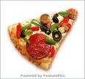  Pizza | 16  Chicken  (Roth)  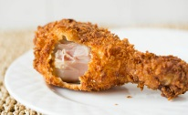  Mac and Cheese and Green Beans  (Roth) | 17  Pack Lunch  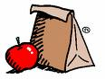  Cortland Skating Rink | 18  Sub Sandwiches  (Ring)  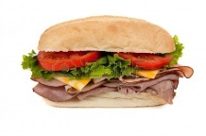  Macaroni Salad  (DeMarco) | 19  Pack Lunch  Hillside Rehab Adaptive Sports | 20
21 | 22  Hot Ham and Cheese  (Merriman)  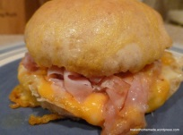  pasta salad  (Schmitt) | 23  Pizza  (Valenti)  Veggie tray  (Morgan) | 24  Pack Lunch  Bowling-Echo Lanes | 25  Pasta and meatballs  (Freeze)  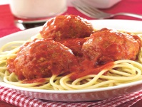  Salad  (Freeze) | 26  Family Picnic  Candlelite Knolls  Please bring-covered dish/dessert | 27
28 | 29  Hotdogs  (Westover)  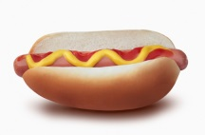  Baked Beans  (Nemcik) | 30  Chicken Mashed Potato Bowls (Wilson)  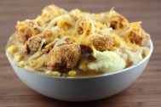  Pasta Salad (Culp)

