Sunday | Monday | Tuesday | Wednesday | Thursday | Friday | Saturday
 |  |  | 1 | 2  Pizza  (Bartone)  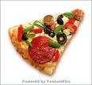  Watermelon  (Bartone) | 3  NO CAMP | 4
5 | 6  Hotdogs  (Marcarello)  Mac and Cheese  (Kello)  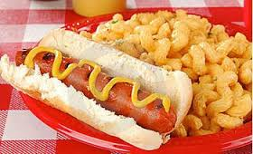  Salad  (Kello) | 7  Walking Tacos  (Price)  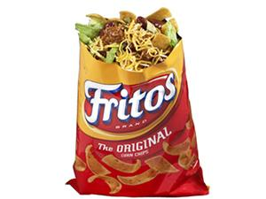  Side: fruit tray  (Morgan) | 8  Pack Lunch  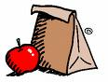  Kent State-Trumbull  Summer Stock Play | 9  Chicken  (Tichnor)  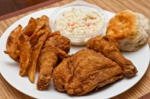  Texas Potatoes  (Tichnor) | 10  Pack Lunch  Pymantuning Spillway | 11
12 | 13  Pizza  (Hull)  Salad  (Ramsey) | 14  Sloppy Joes  (Guy)  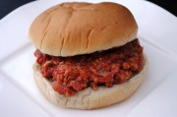  Pasta salad  (Galela) | 15  Pack Lunch  Middlefield Sprinkler Park | 16  Appreciation Tea Celebration  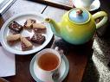  Please bring a side dish! | 17  Last Day  Movie | 18
19 | 20 | 21 | 22 | 23 | 24 | 25
26 | 27 | 28 | 29 | 30 | 31

