Sunday | Monday | Tuesday | Wednesday | Thursday | Friday | Saturday
 |  |  | 1  Cleveland Zoo  Depart 8:30 (campers must be dropped off @8:00 am and picked up @4:00pm) | 2 | 3  NO CAMP | 4
5 | 6 | 7 | 8  Kent Trumbull Traveling Summer Stock Performance  10:00 @ North Road | 9 | 10  Pymantuning Spillway  10:00 arrival | 11
12 | 13 | 14 | 15  Middlefield Sprinkler Park  10:00 arrival  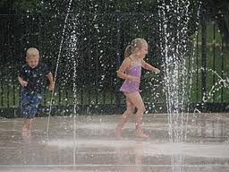 | 16  Appreciation Tea Celebration  11:00  Please bring a covered dish | 17  Last Day  Movie  @ Fairhaven | 18
19 | 20 | 21 | 22 | 23 | 24 | 25
26 | 27 | 28 | 29 | 30 | 31

